Project 1

Clone the source code to local machine
Step 1: Docker
Dockerfile (React app served by Nginx)
FROM nginx:alpine

# Remove default config
RUN rm /etc/nginx/conf.d/default.conf

# Copy custom config (must be in repo root)
COPY nginx.conf /etc/nginx/conf.d/default.conf

# Copy built React app (dist or build folder)
WORKDIR /usr/share/nginx/html
COPY dist/ .

EXPOSE 3000
CMD ["nginx", "-g", "daemon off;"]

nginx.conf
server {
listen 3000;
server_name localhost;

root /usr/share/nginx/html;
index index.html;

location / {
try_files $uri /index.html;
}
}
Build & Run:
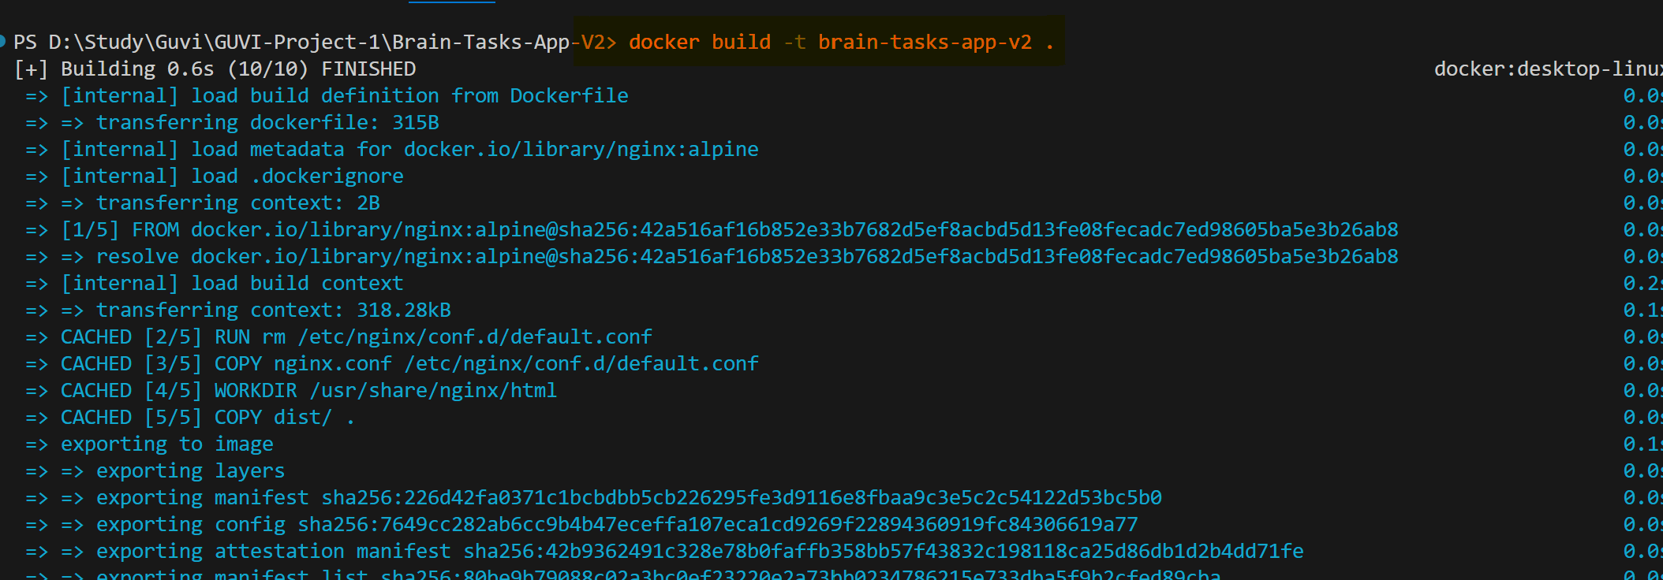


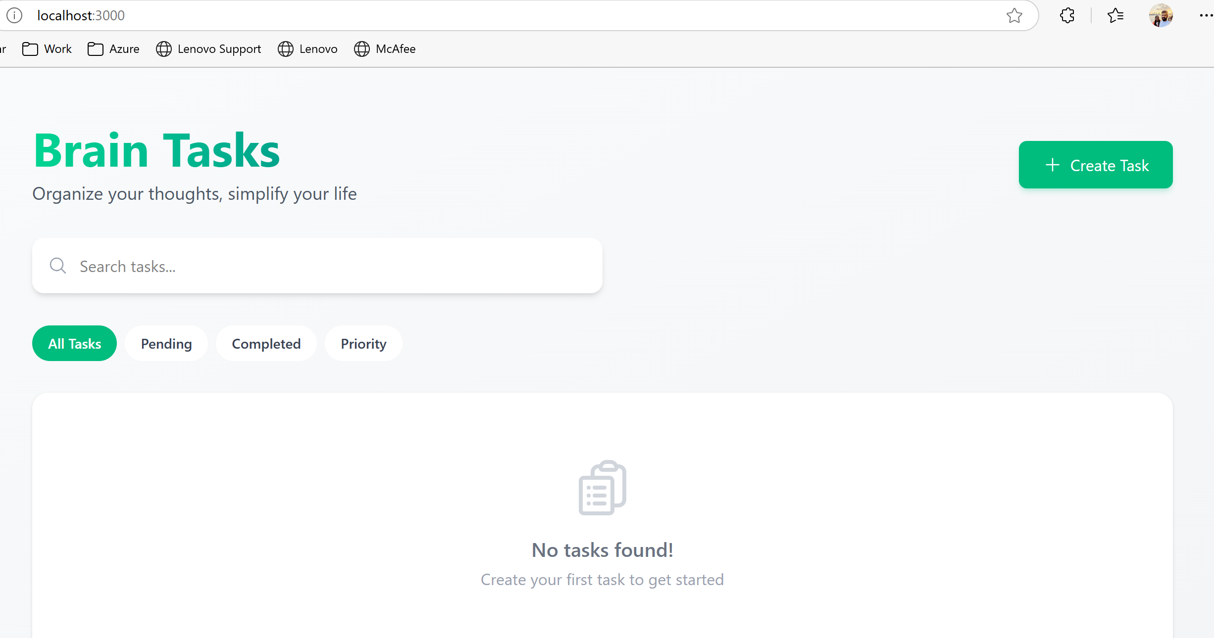

Step 2: ECR
ECR: repository and image push
Create ECR:
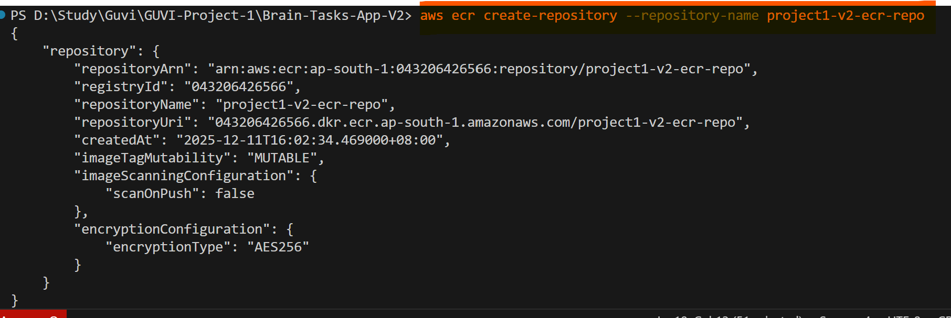 Authenticate and tag:

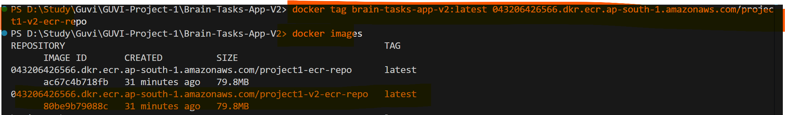
Push:
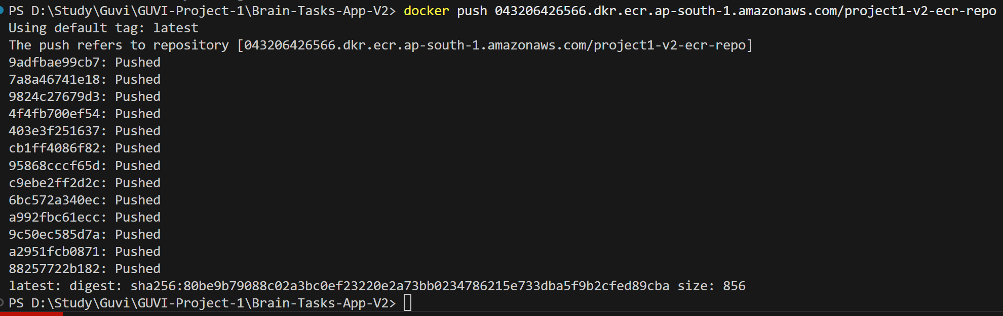

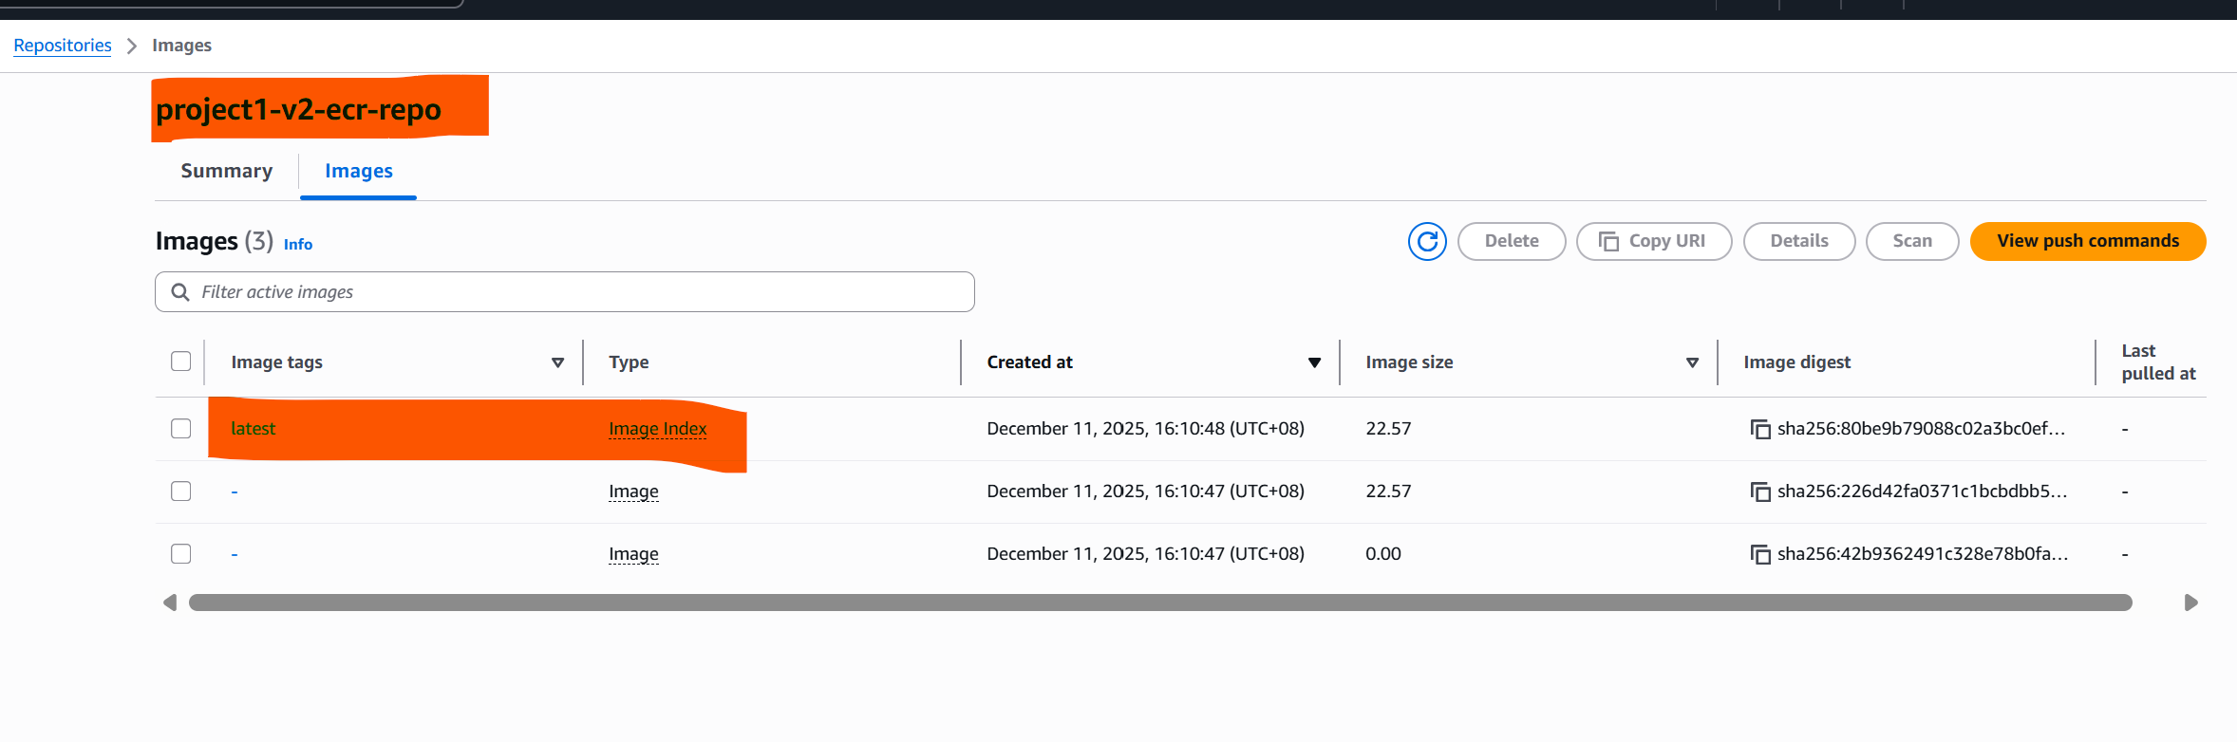
STEP 3: EKS: cluster setup and access
Create EKS cluster

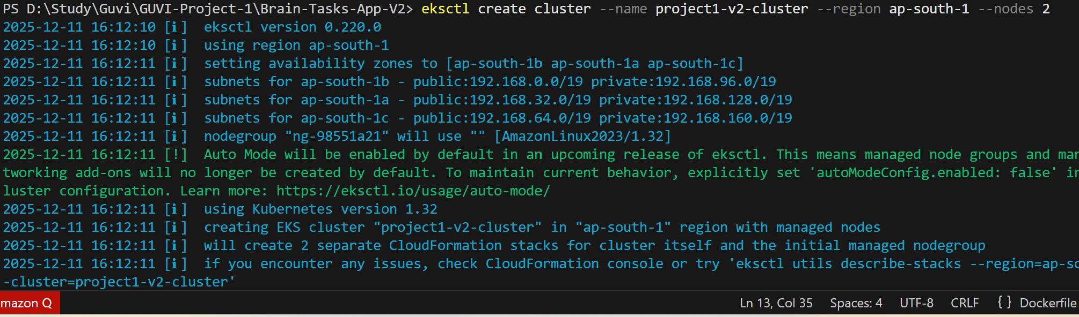

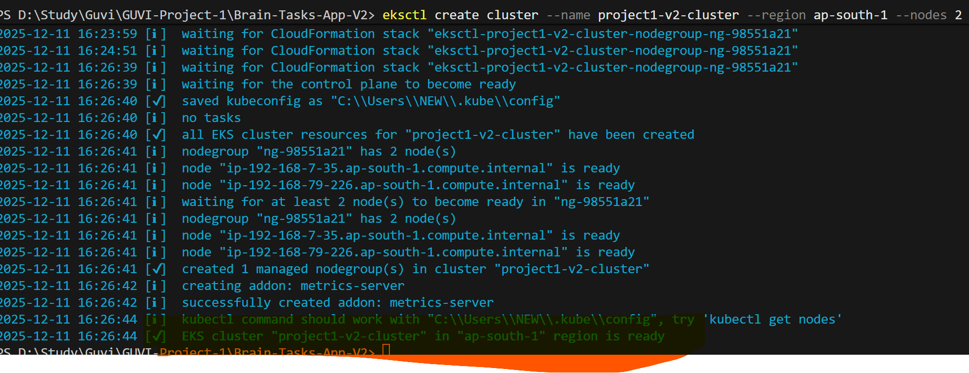

Created below IAM Access entry in EKS
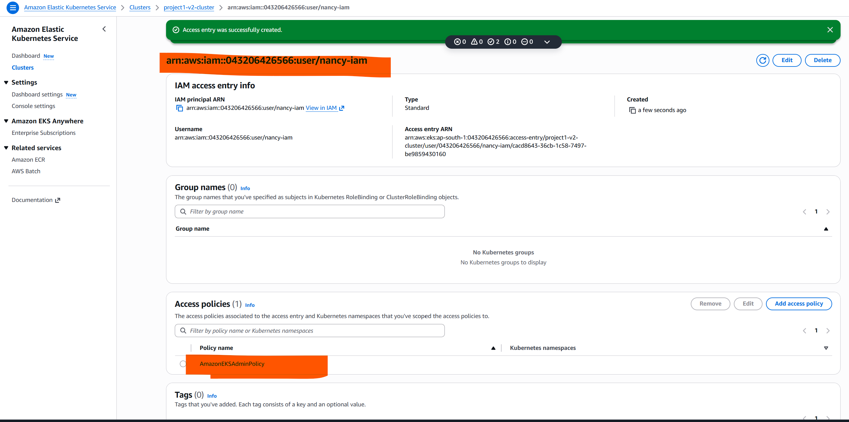

Kubernetes Deployment & Service

STEP 4: CI/CD Code Build ,Code Deploy and CodePipeline

buildspec.yml (build and push to ECR, publish k8s artifacts)
Flow Summary
- Login to ECR (pre_build).
- Build Docker image locally (build).
- Tag image with ECR repo URI (build).
- Push image to ECR (post_build).
Note:
CodeDeploy integrates with Kubernetes so we can skip appspec.yaml.
When you do need appspec.yaml
- CodeDeploy is explicitly part of your pipeline:
If you’re using AWS CodeDeploy to orchestrate deployments (with lifecycle hooks like BeforeInstall, AfterInstall, ApplicationStart, etc.), then you must provide an appspec.yaml.
- EC2/On-Premises or ECS deployments:
For these environments, appspec.yaml is mandatory because CodeDeploy uses it to know what files to copy and which scripts to run

Kubernetes via CodePipeline → CodeBuild → kubectl:
If your pipeline is simply applying Kubernetes manifests (deployment.yaml, service.yaml) directly to your EKS cluster, you don’t need appspec.yaml. The manifests themselves are the deployment definition.
Quick rule of thumb
- Pipeline → CodeBuild → kubectl apply → No appspec.yaml.
- Pipeline → CodeDeploy → lifecycle scripts → Yes, appspec.yaml.
STEP 5: GIT
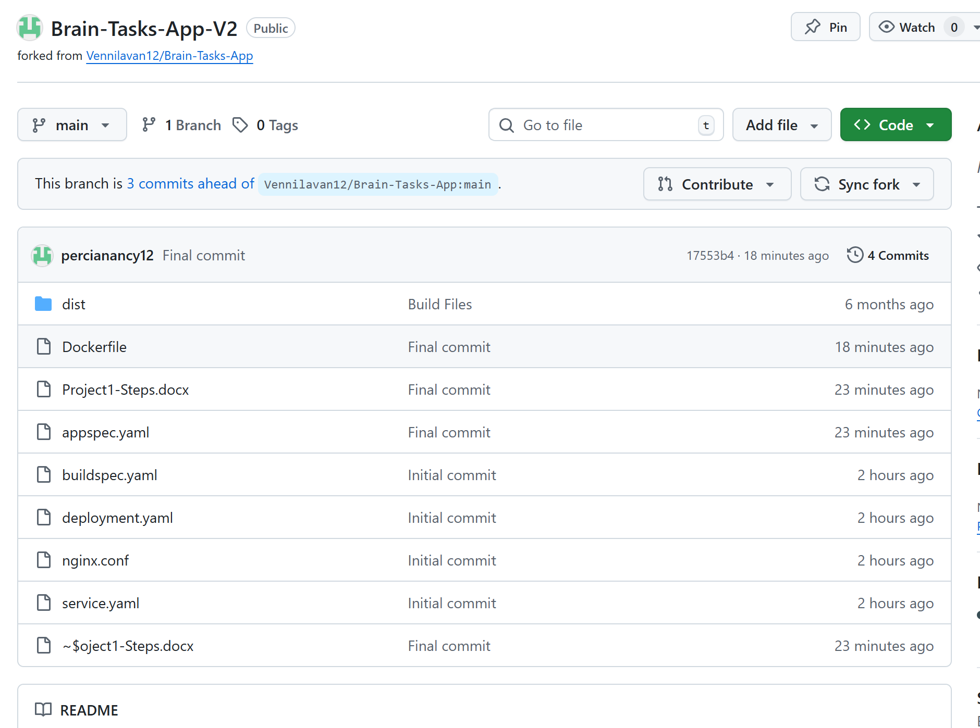
CodeBuild Steps:
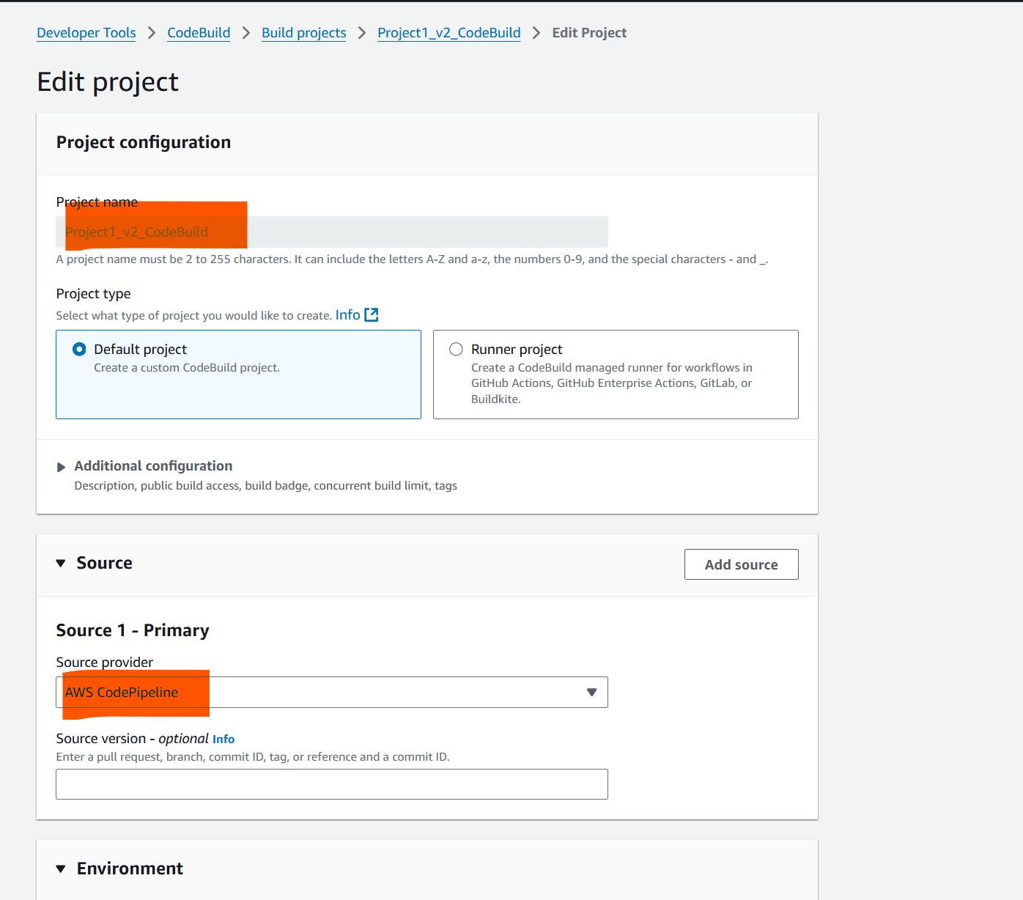
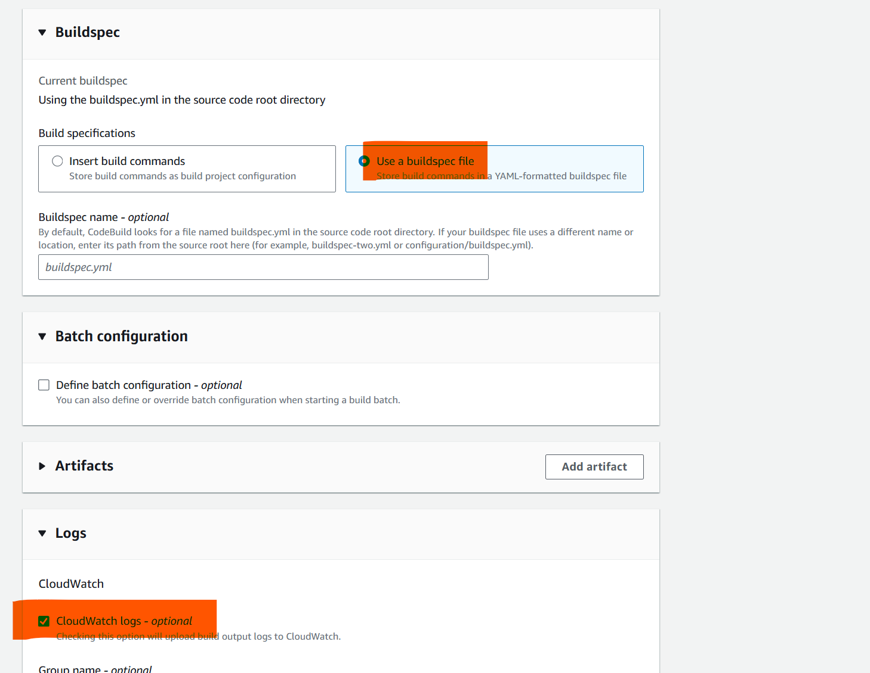

CodePipeline Steps:

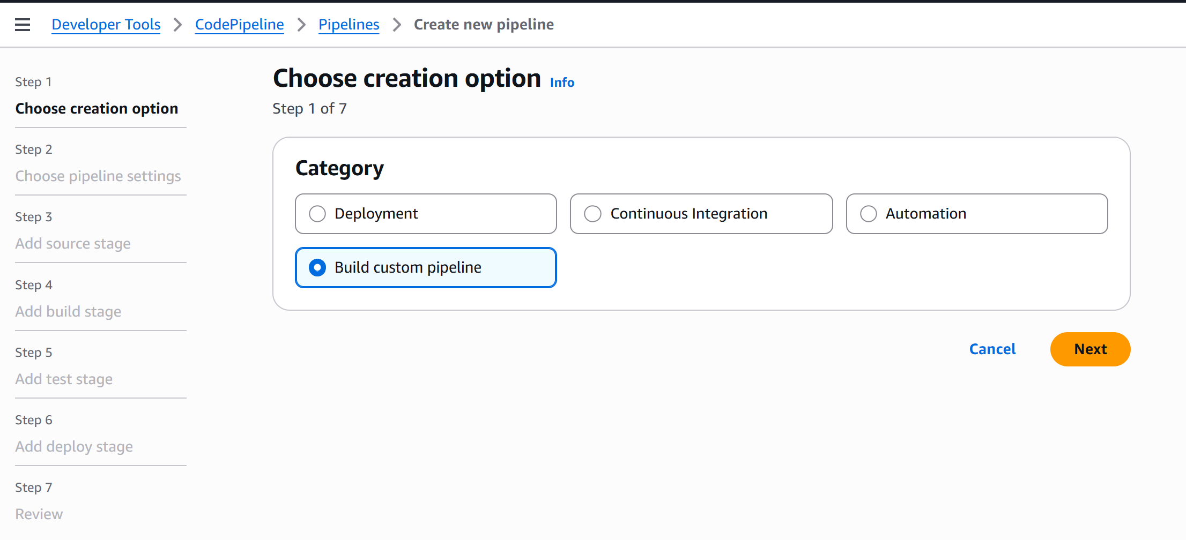

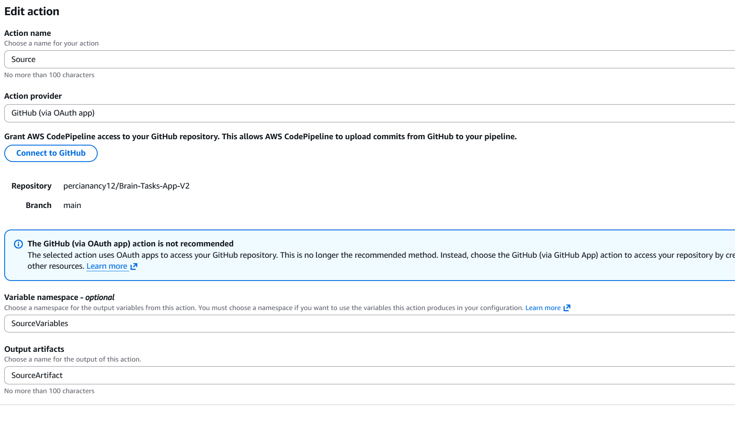

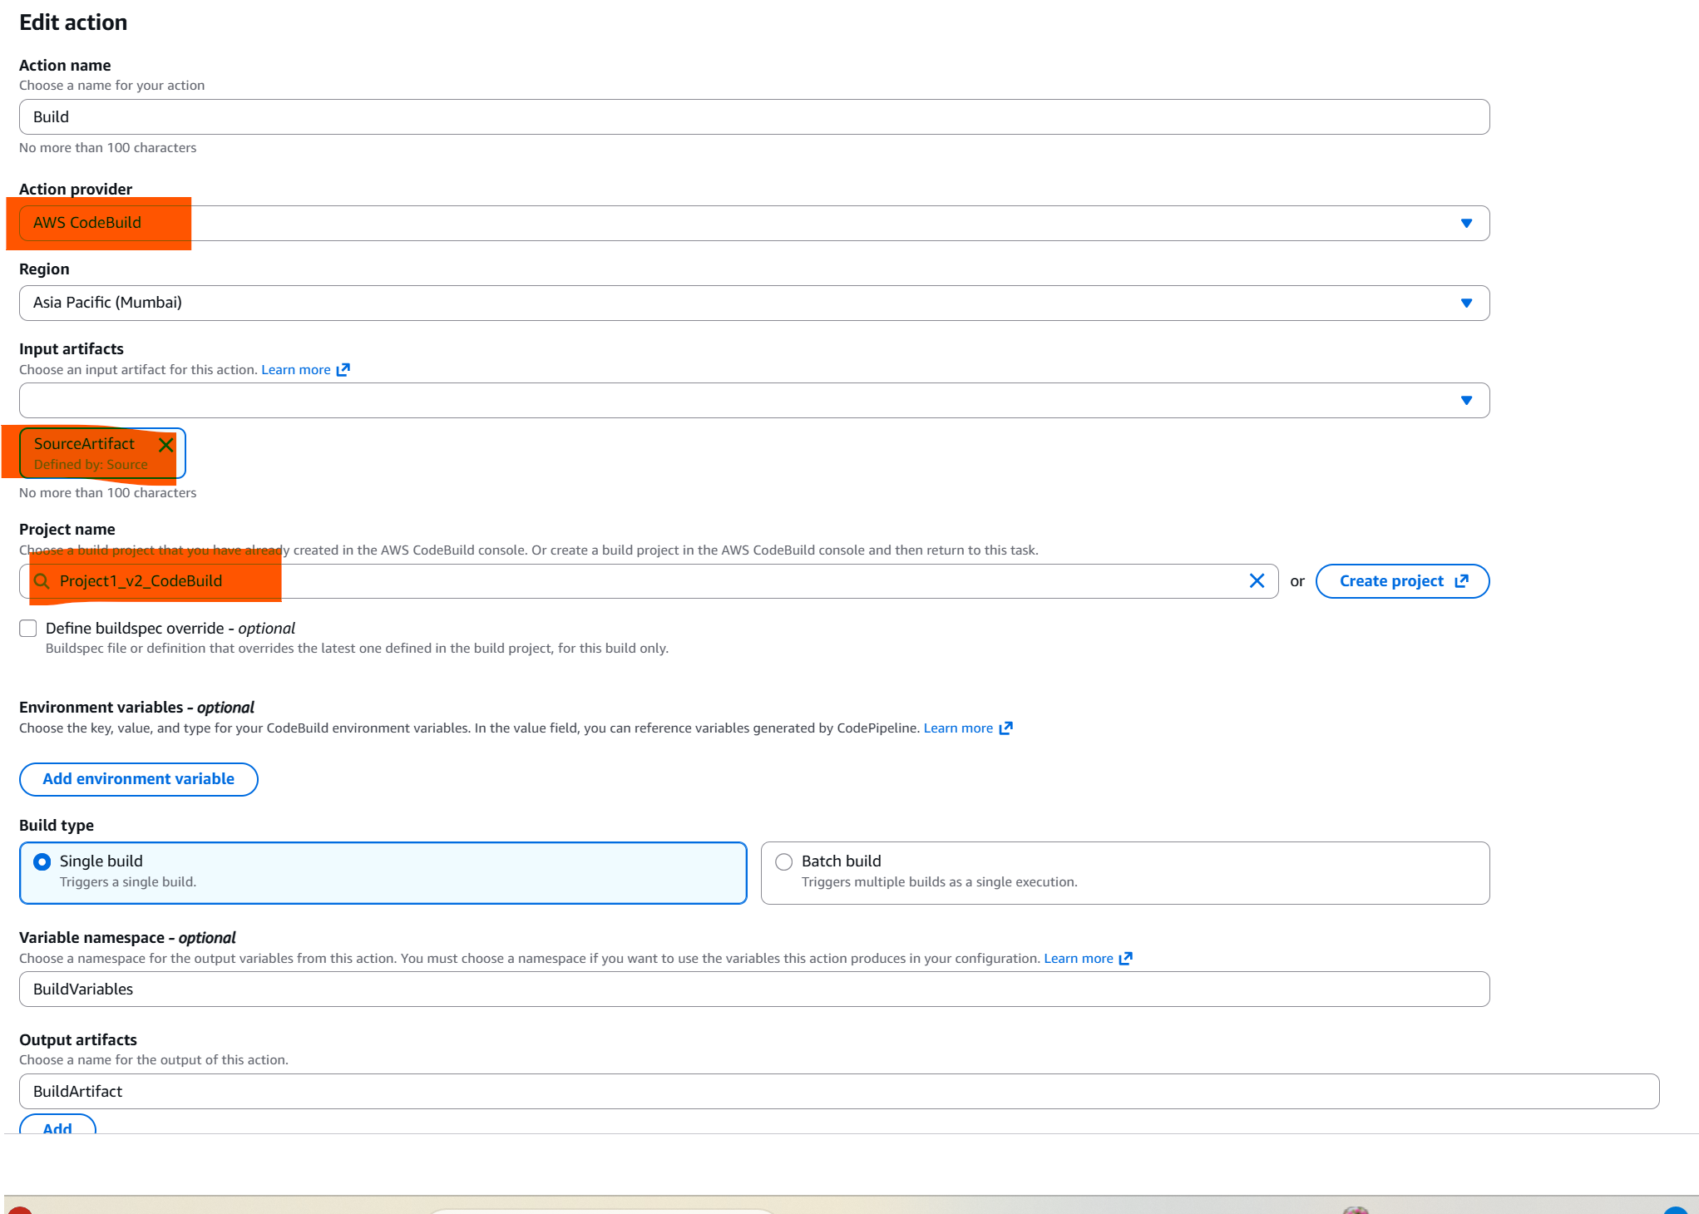

Code Deploy
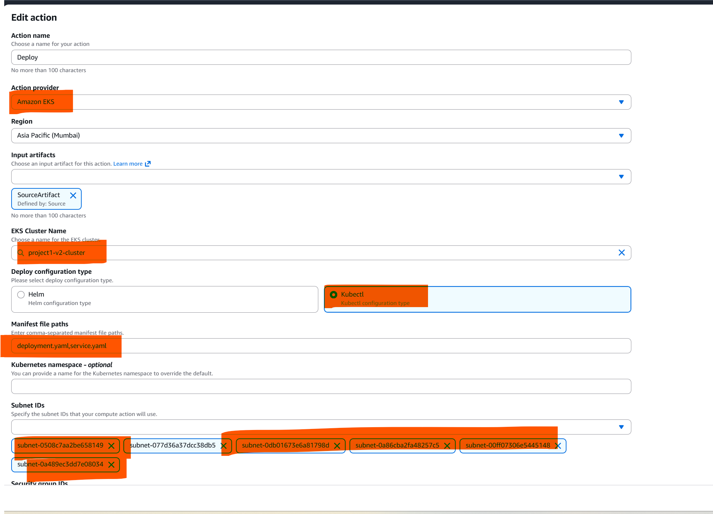
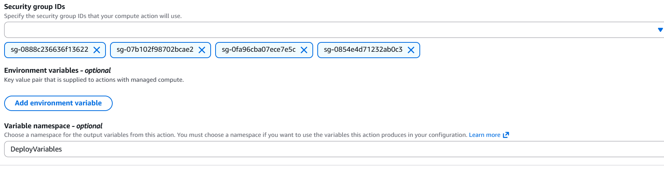

Once Code pipeline starts encountered below errors

Latest action execution message
Build terminated with state: FAILED. Phase: PRE_BUILD, Code: COMMAND_EXECUTION_ERROR, Message: Error while executing command: aws ecr get-login-password --region ap-south-1 | docker login --username AWS --password-stdin 043206426566.dkr.ecr.ap-south-1.amazonaws.com. Reason: exit status 1

IAM fix by adding policy in build pipeline service role
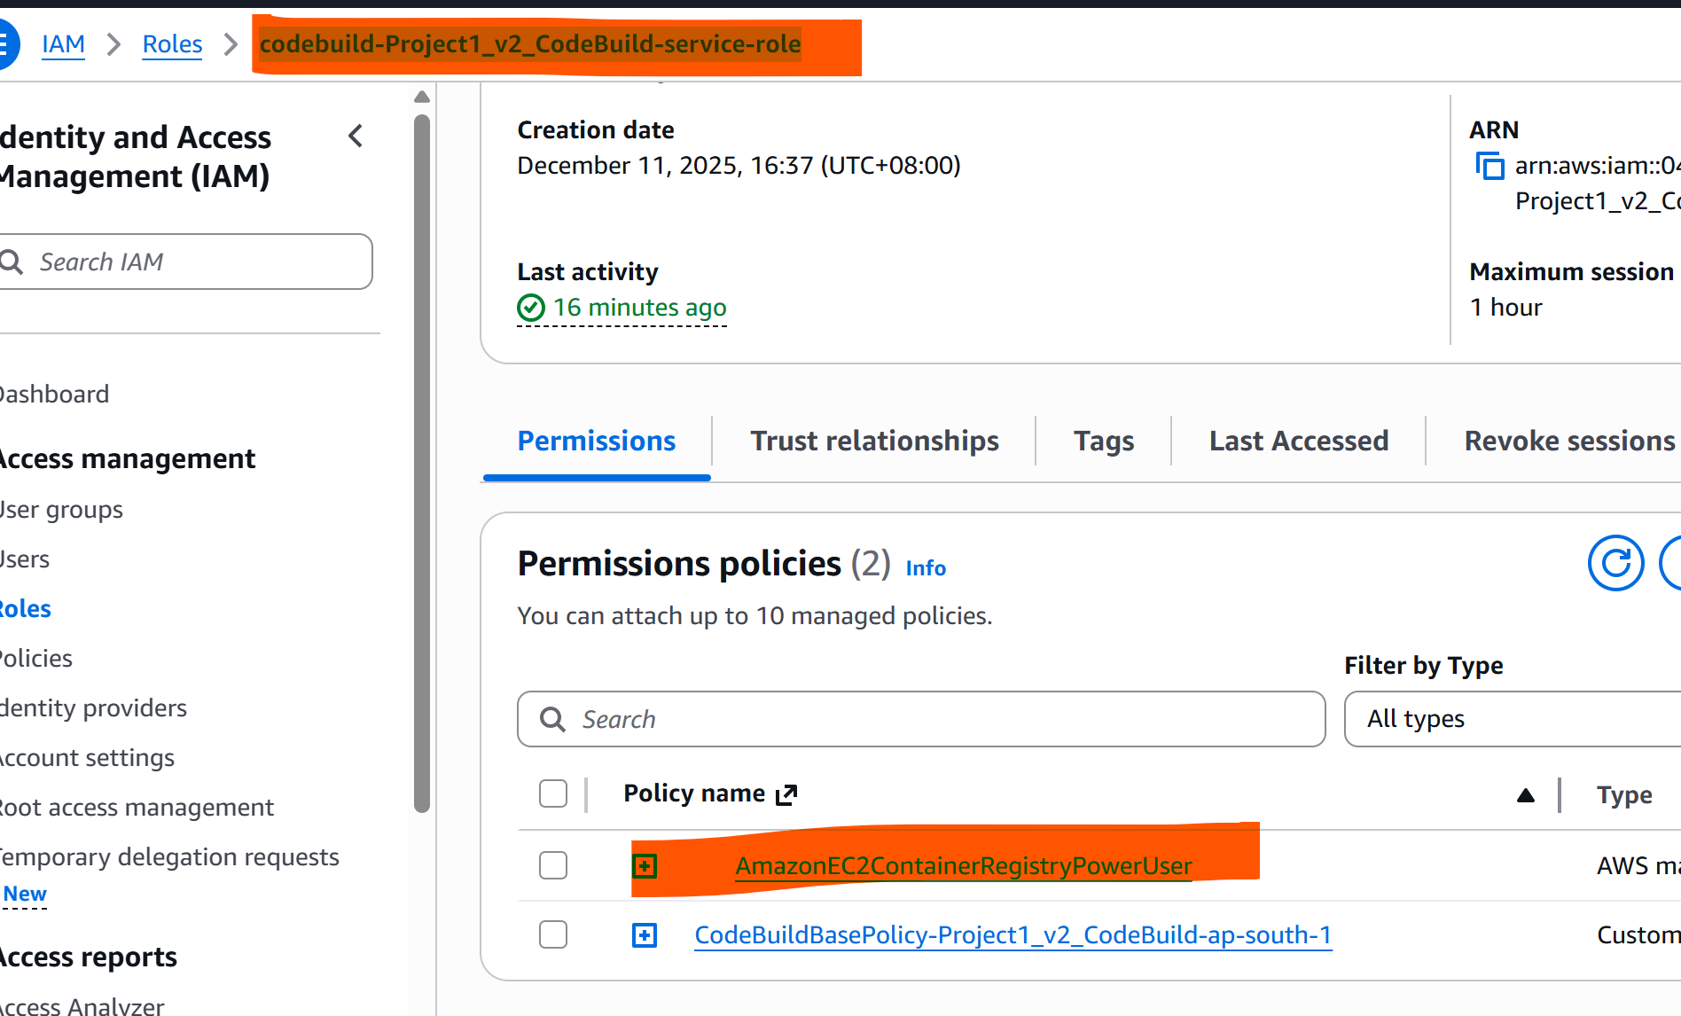

To fix tis

Latest action execution message

Error running command kubectl apply -f deployment.yaml -f service.yaml Command failed: kubectl apply -f deployment.yaml -f service.yaml error validating "deployment.yaml": error validating data: failed to download openapi: the server has asked for the client to provide credentials; if you choose to ignore these errors, turn validation off with --validate=false error validating "service.yaml": error validating data: failed to download openapi: the server has asked for the client to provide credentials; if you choose to ignore these errors, turn validation off with --validate=false Please add your action's role as an access entry in your eks cluster.

You need to add this IAM role as an access entry in your EKS cluster so it can run kubectl commands.
Option 1: Using AWS Console
Go to Amazon EKS → Clusters → project1-cluster → Access → Access entries.
Click Create access entry.
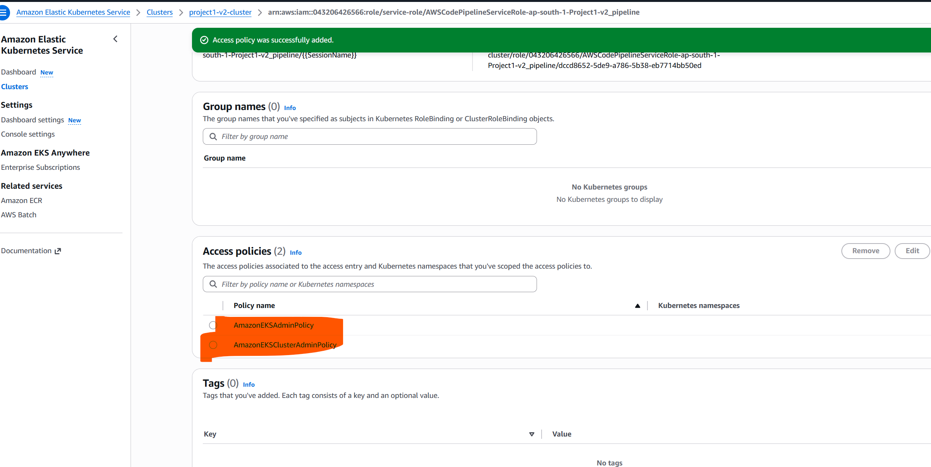
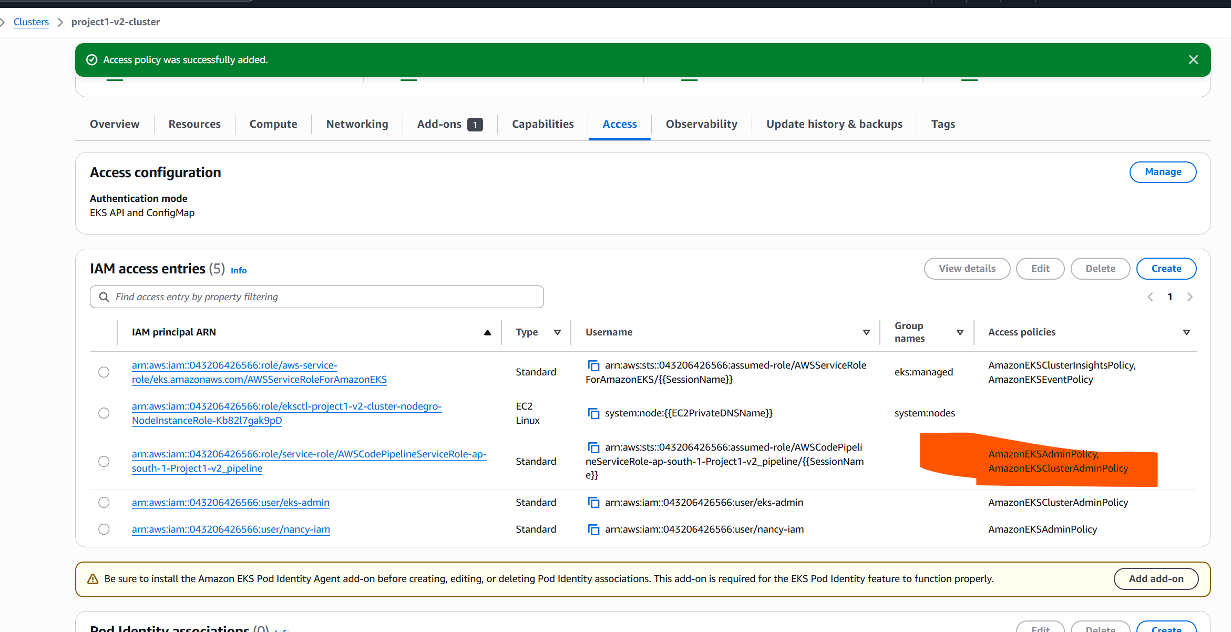

Then Add the Role to aws-auth ConfigMap
even though added the role via the Access tab, some clusters still require the role to be explicitly mapped in aws-auth. That’s why the error persists.
Here’s what to do:
- Open the aws-auth ConfigMap
kubectl edit configmap aws-auth -n kube-system

2. Add this block under mapRoles:
- rolearn: arn:aws:iam::043206426566:role/AWSCodePipelineServiceRole-ap-south-1-Project1-v2_pipeline
username: pipeline
groups:
- system:masters

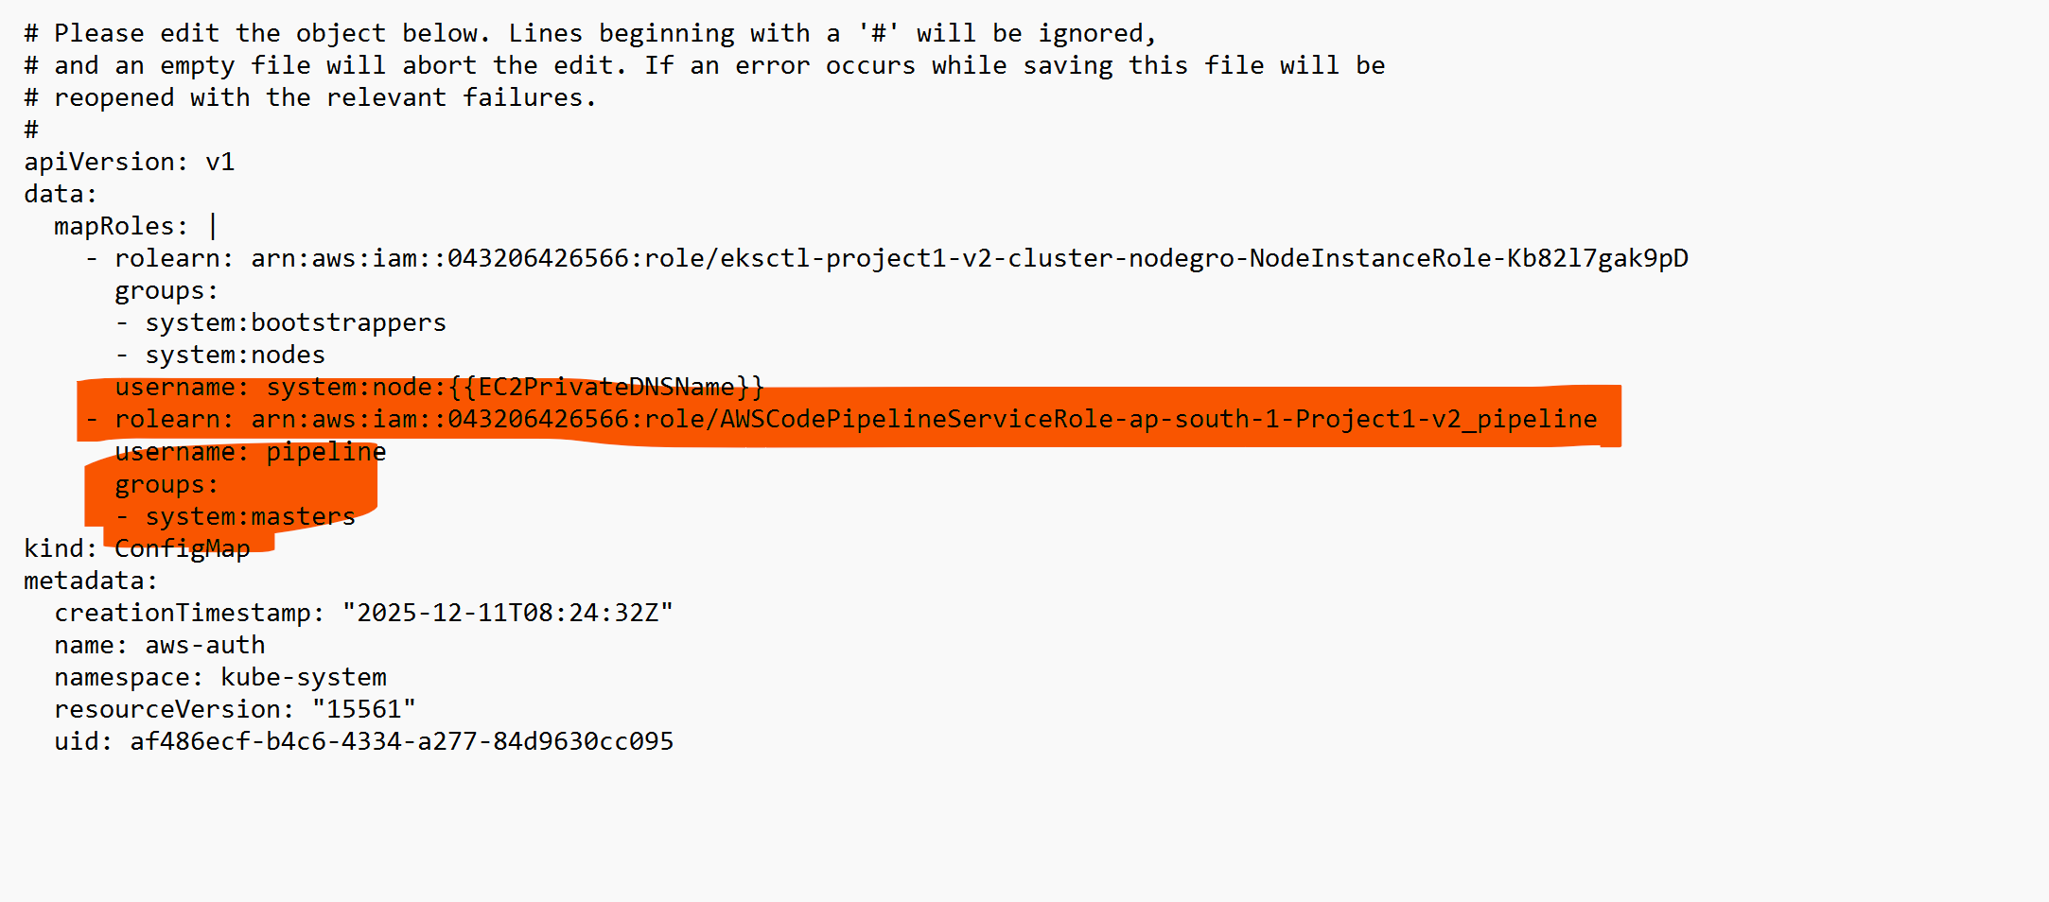
Once edited verify using below command

kubectl get configmap aws-auth -n kube-system -o yaml

Ouput:
Application deployed kubernetes Loadbalancer ARN in port 3000
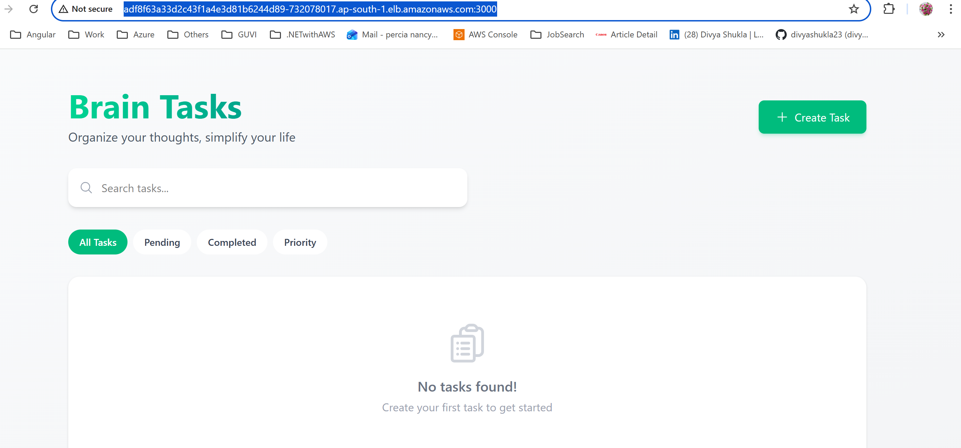

Cloud Watch Logs
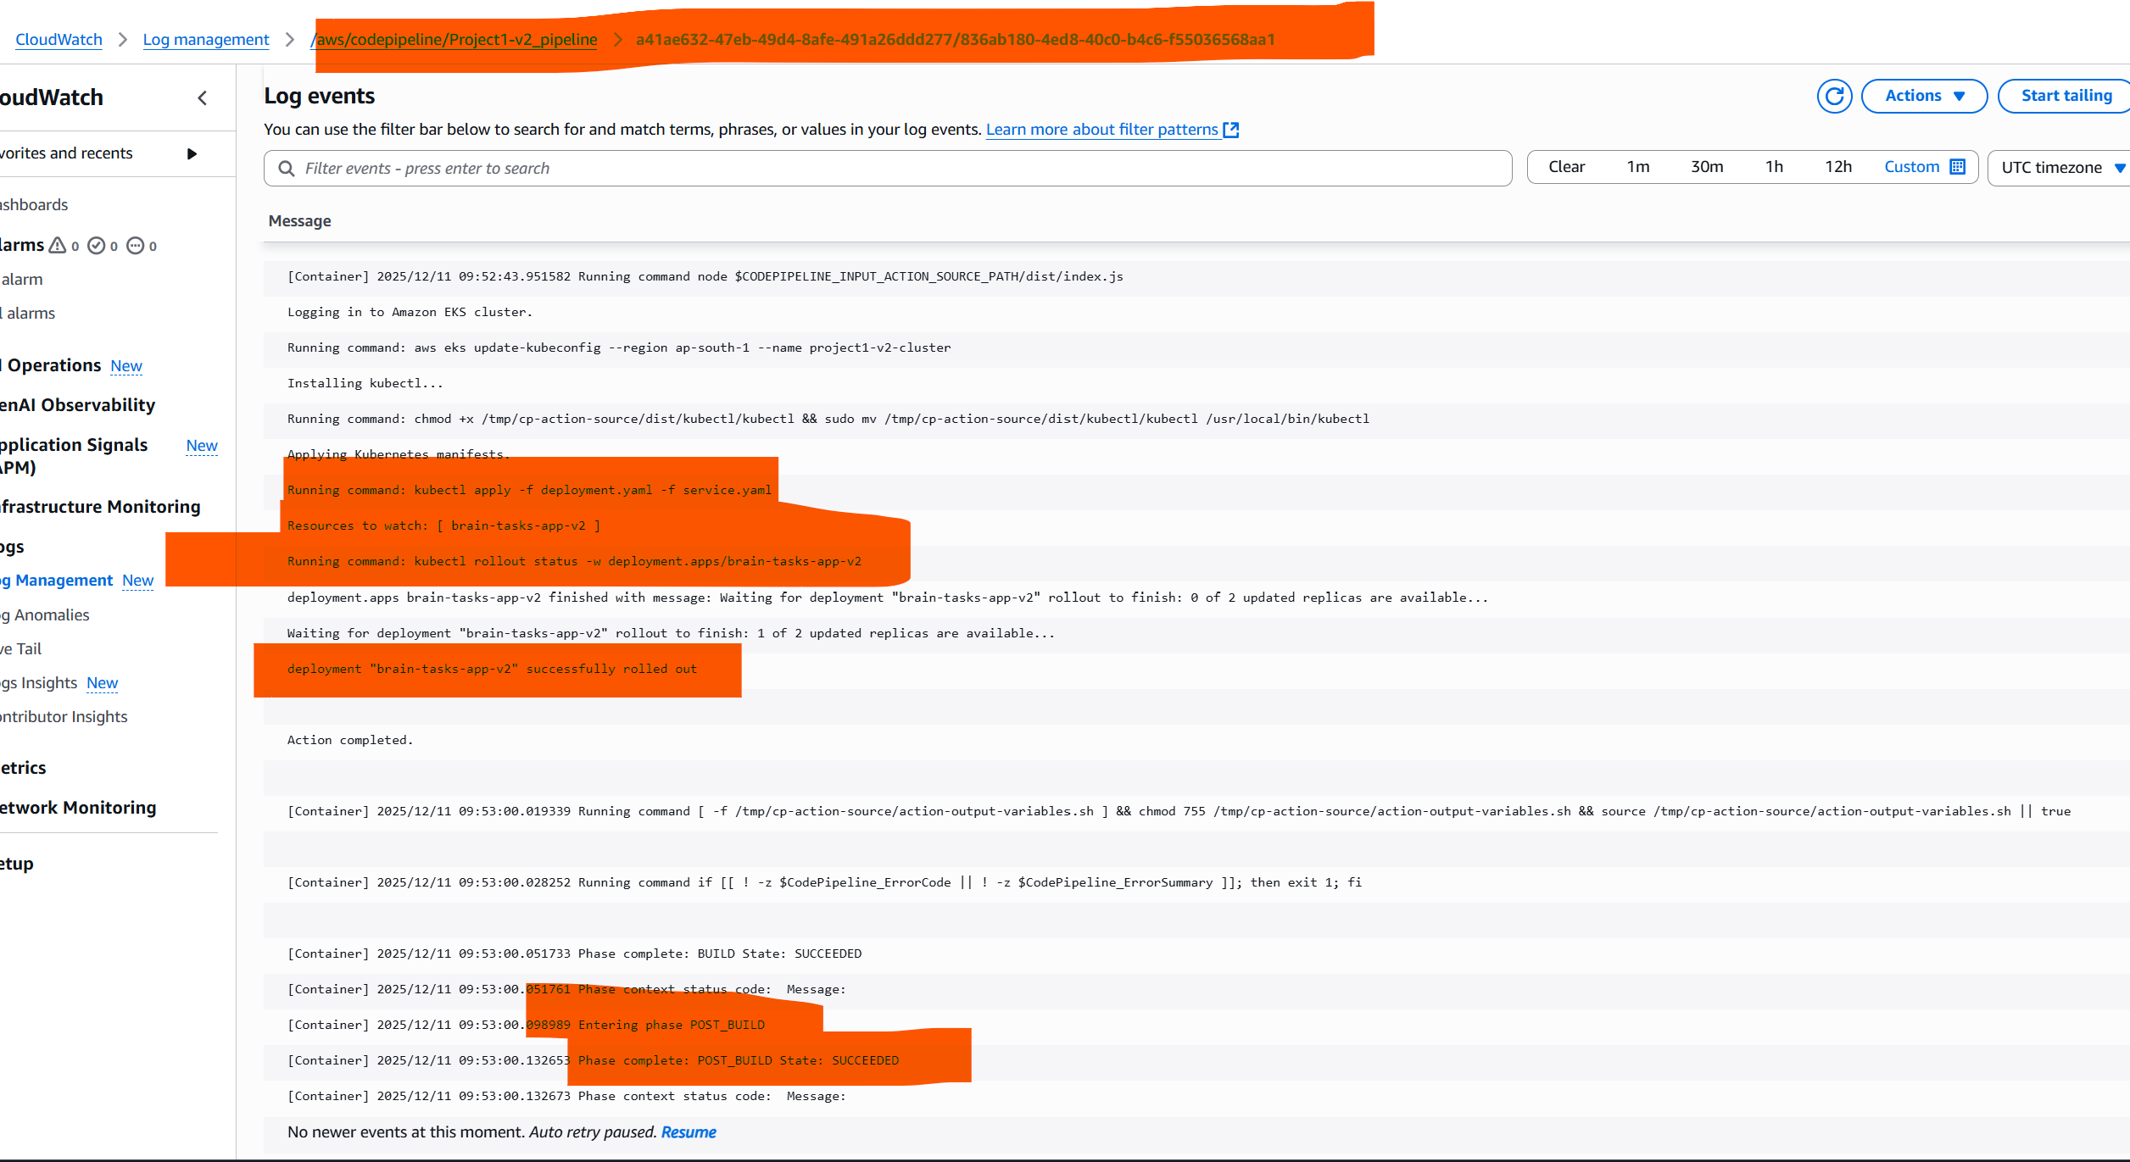

Pipeline
